Project 2012-INT-06 Interpretation for
Consumers Energy
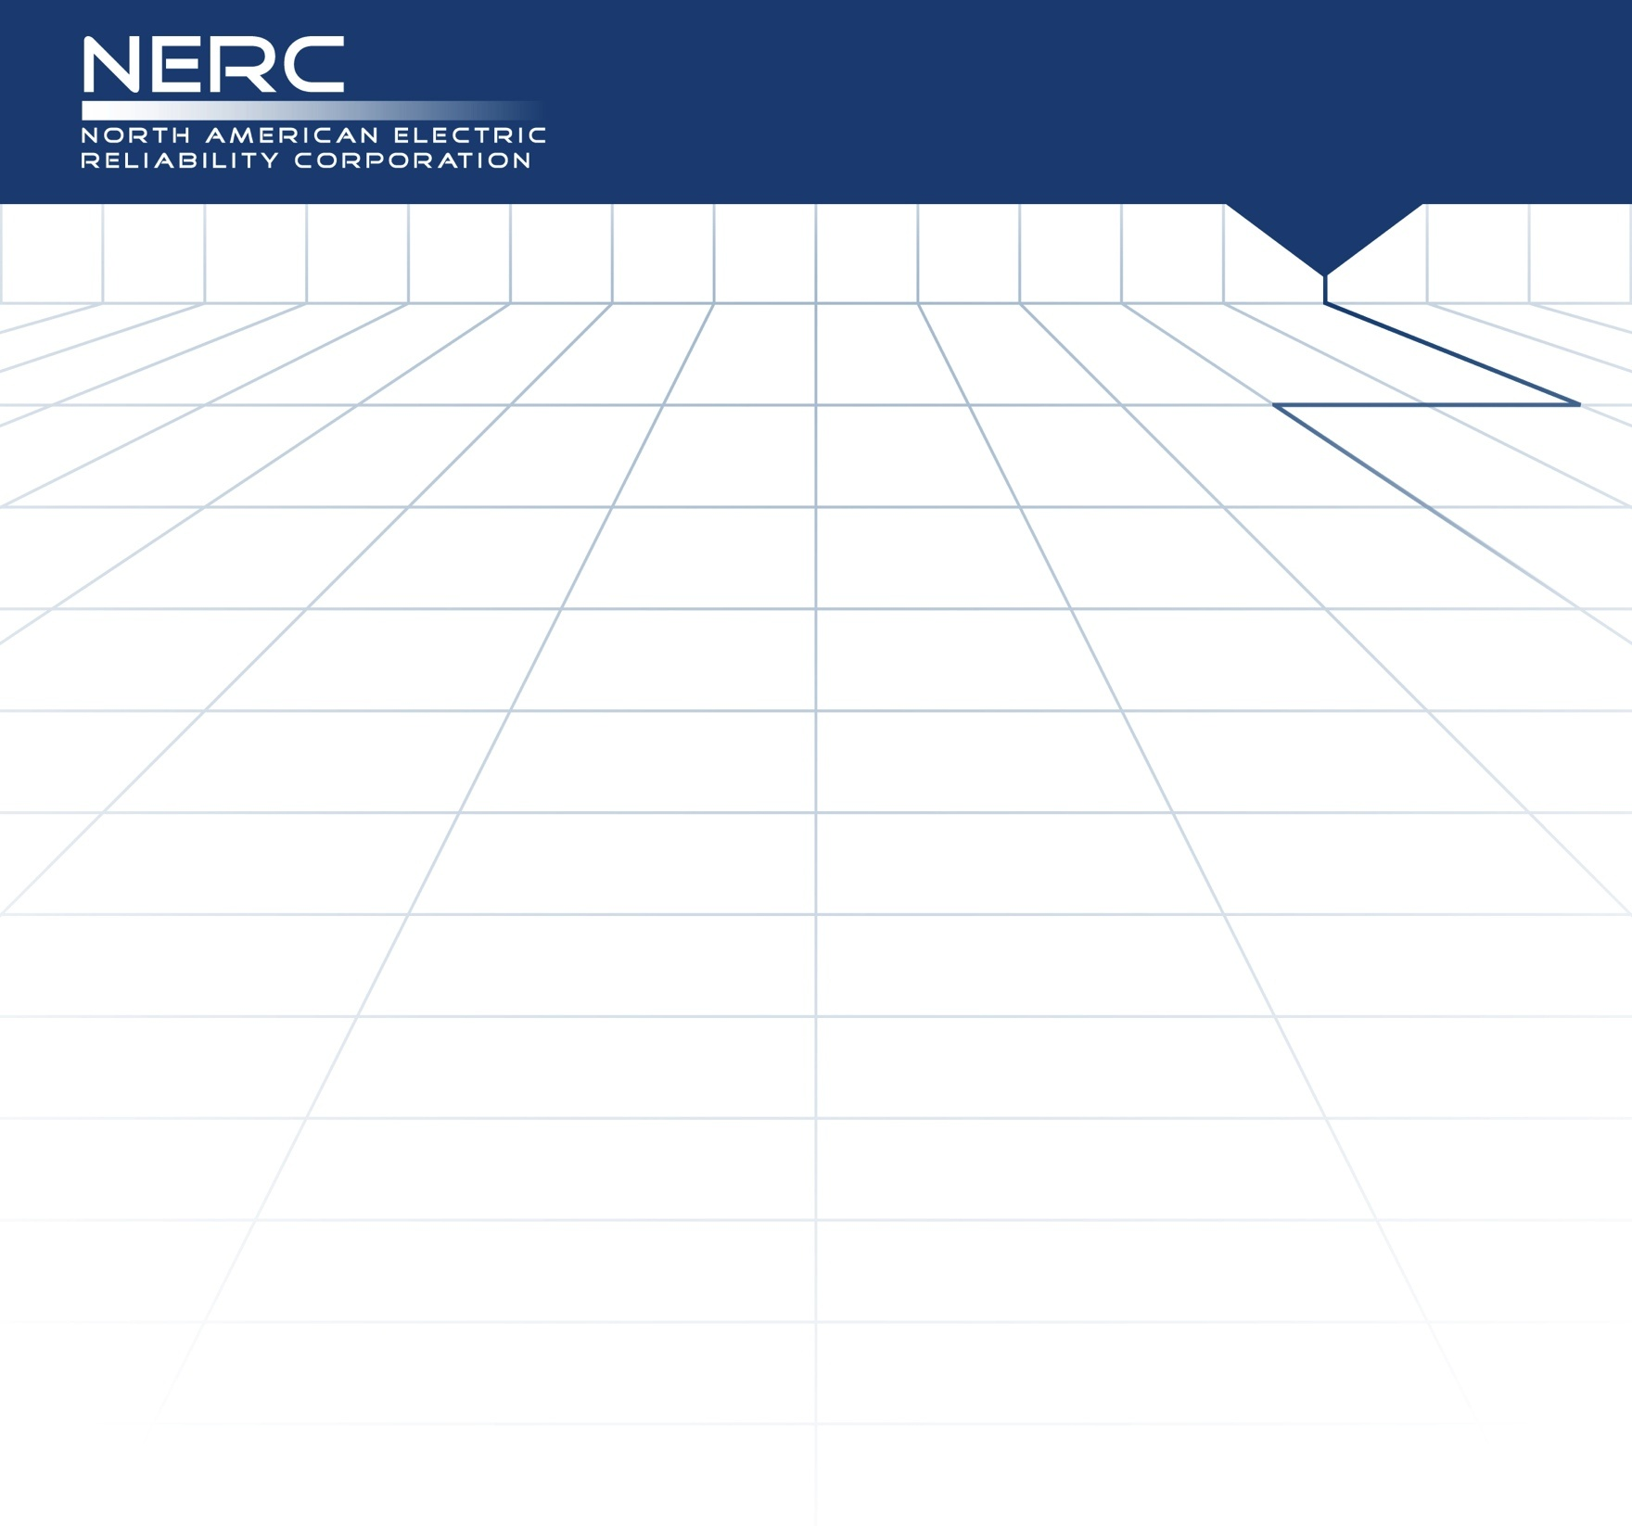
Unofficial Comment Form
Project 2012-INT-06 Interpretation of CIP-003-3
Applicability Section and Requirement R2, for Consumers Energy

Please DO NOT use this form to submit comments. Please use the electronic comment form to submit comments on the Interpretation of CIP-003-3, Applicability Section and Requirement R2, for Consumers Energy (Project 2012-INT-06). The electronic comment form must be completed by 8 p.m. ET December 10, 2012.

Project Page

If you have questions please contact Steven Noess at Steven.Noess@nerc.net or by telephone at 404.446.9691.

Background Information:
In May 2011, the Standards Committee appointed a standing CIP Interpretation Drafting Team (IDT) for the development of CIP Interpretations. A project team from the CIP IDT has reviewed Consumers Energy’s request for interpretation (RFI) and developed this interpretation pursuant to the NERC Guidelines for IDTs. (Available at: Guidelines for Interpretation Drafting Teams)

The stated purpose of CIP-003-3 requires that Responsible Entities have minimum security management controls in place to protect Critical Cyber Assets.

The IDT first examined the Consumers Energy RFI in an effort to identify the core question being asked. Consumers Energy references the applicability section of CIP-003-3, “Applicability” specifies that a “Responsible Entity” shall mean…”, and lists several functions. The Rules of Procedure further clarify that a “Responsible Entity” means an entity that is registered for a reliability function in the NERC Compliance Registry and is responsible for complying with an Applicable Requirement, as specified in the “Applicability” section of the CIP Standard. If one substitutes any of these functions for the term “Responsible Entity”, it would appear that there could be a different Senior Manager for each function to which that entity is registered. Consumers Energy specifically requested clarification on whether a Registered Entity can assign different CIP Senior Managers for different applicable functions for which it is registered.

The applicability of NERC Reliability Standards, including CIP, is based on the Organization Registration and Certification requirements outlined in the NERC Rules of Procedure. As a result, the IDT has considered the terms registered entity, responsible entity and functional entity in the evaluation of this RFI. The IDT determined that a registered entity is equivalent to the organization that is associated with a specific NERC entity registration id, as listed in the NERC Compliance Registry. While a responsible entity is the entity performing a function (if only one performed), or collection of functions, associated with the entity identified in the NERC Compliance Registry. Therefore the responsible entity list of functional entities found within the applicability section of the CIP-003 standard would be treated as a collection of the functions that a given registered entity performs.

This approach of viewing the functions listed within the applicability section as a collection of functions associated to the registered entity is re-enforced through the NERC audit process. This is done in such a manner that the regions schedule the appropriate three year or six year audit for a registered entity based on the collection of functions performed by a given entity. In the conducting of the scheduled audit, the entity is responsible to demonstrate compliance to the standards that are applicable to the functions the entity is registered as.

In the case of CIP-003 R2 if a registered entity is scheduled for an audit and the entity is registered to perform any of the functions listed within the applicability section of CIP-003 R2 then the registered entity needs to demonstrate scrict compliance with the requirements of CIP-003 R2. In order for a registered entity to demonstrate strict compliance with CIP-003 R2 they would need to provide evidence that they have assigned a single CIP Senior Manager with overall responsibility and authority for leading and managing the entity’s implementation of, and adherence to, Standards CIP-002-3 through CIP-009-3.

The audit process described above does not preclude an entity from altering the entity registration to achieve different result for CIP-003 R2, however there are many items to consider when evaluating an entity registration.

For discussion and demonstration purposes the IDT has provided four examples in which an entity could achieve varying results to CIP-003 R2. All four examples are consistent with the IDT interpretation that a single registered entity needs to identify a single CIP Senior Manager and therefore the phrase “Responsible Entity” is interpreted as a collection of the functions performed under a single registered entity.

Questions:
You do not have to answer all questions. Enter All Comments in Simple Text Format.
Insert a “check” mark in the appropriate boxes by double-clicking the gray areas.
Please review the request for an interpretation, the associated standard, and the draft interpretation and then answer the following questions.

- Do you agree with this interpretation? If not, what, specifically, do you disagree with? Please provide specific suggestions or proposals for any alternative language.

Yes
No
Comments:

